SMART AMBULANCE TRAFFIC SIGNAL SYSTEM

Problem:
During an emergency, an ambulance can lose critical time at several stages of its journey—from receiving the emergency call and identifying the accident location to reaching the patient and transporting the patient to a suitable hospital. In rural and semi-urban areas, callers may describe locations using unclear landmarks, making the exact incident location difficult to identify.
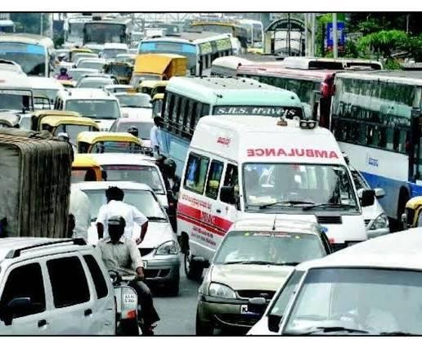
An Ambulance stuck in traffic
After dispatch, the ambulance may face unfamiliar roads, heavy traffic, traffic signals, railway crossings, blocked intersections and vehicles that are unaware of the approaching emergency vehicle. Even after reaching the accident scene, the journey to the hospital can be delayed again because traffic conditions may have changed. A traffic signal turning green alone does not guarantee that the route ahead is clear. Therefore, the problem is not only traffic-signal delay, but the lack of a coordinated system that can support the ambulance journey from emergency call to accident scene and from accident scene to hospital.

Solution:
We propose a hybrid software-and-hardware Smart Ambulance Traffic Signal System designed to support an ambulance throughout its complete emergency journey—from receiving the emergency call to reaching the accident scene and finally transporting the patient to a suitable hospital. Instead of focusing only on changing a traffic signal, the proposed system combines AI-assisted location identification, dynamic route planning, traffic prediction, V2X/RF communication, driver alerts, coordinated traffic-signal control and hospital-route management.
When an emergency call is received, the system first assists in identifying and verifying the exact incident location from the information provided by the caller. If the caller describes the location using landmarks or local references, the software can use available location information, map data and the caller's description to determine the most likely incident point. This reduces the need for repeated communication between the ambulance driver and the caller and helps the ambulance reach unfamiliar locations more efficiently.
Once the incident location is identified, the system generates multiple feasible routes between the ambulance and the accident location. Instead of selecting a route only according to distance, the system considers current traffic conditions and predicted traffic conditions to estimate the expected travel time of each route. An AI/ML-based prediction component can help estimate how traffic may change while the ambulance is travelling. The route with the most suitable predicted emergency travel time is then selected, while the system continues monitoring conditions so that the route can be changed if a major blockage or unexpected congestion develops.
After the route is selected, the system creates a dynamic emergency corridor along the ambulance's predicted path. The ambulance is equipped with a communication unit that can transmit its emergency status, identification, position and direction. In the physical prototype, a low-cost RF communication system and microcontroller can demonstrate this emergency communication, while the future system can use V2X communication to communicate with connected vehicles and roadside infrastructure. This extends the original traffic-signal concept from a single junction to a coordinated emergency route.
As the ambulance approaches upcoming junctions and other important points on the route, the system estimates its arrival time using its current position and speed. Traffic infrastructure can then be prepared before the ambulance arrives. Traffic signals can provide coordinated emergency priority when appropriate, rather than simply changing to green immediately whenever an ambulance is detected. Nearby connected vehicles can receive emergency warnings, while other available roadside traffic management systems can be used to provide information to road users. This helps drivers become aware of the approaching ambulance and provides them an opportunity to give way safely.
The system can also monitor traffic conditions along the planned route using available traffic sensors or cameras. If a queue, blocked intersection or unexpected congestion is detected ahead, the system can reassess the situation and determine whether the current route should continue or whether an alternative route would reduce the predicted delay. Therefore, the system is designed to prepare for traffic conditions before the ambulance reaches them, rather than reacting only after the ambulance becomes stuck.
While the ambulance is travelling to the accident location, the emergency-response system can also collect important information from the caller, such as what happened, the number of people involved and the symptoms or condition being reported. The system can organize this information for the emergency team and provide verified basic first-aid guidance to the caller while the ambulance is on its way. This information can later assist the emergency team in understanding the situation before reaching the patient.
After the ambulance reaches the accident scene and the patient's condition is assessed, the system begins a second emergency journey—from the accident scene to the hospital. Instead of automatically selecting the nearest hospital, the system can identify suitable and reachable hospital options based on the reported medical requirements, available emergency facilities, distance and predicted travel time. The final destination can be confirmed by the appropriate medical or emergency service personnel. Alert speakers installed at traffic signals can provide an audible warning when an ambulance is approaching. The speaker can announce an emergency alert such as “Emergency ambulance approaching. Please give way safely.” This can help alert drivers who may not notice visual signals or the approaching ambulance, especially at crowded intersections.
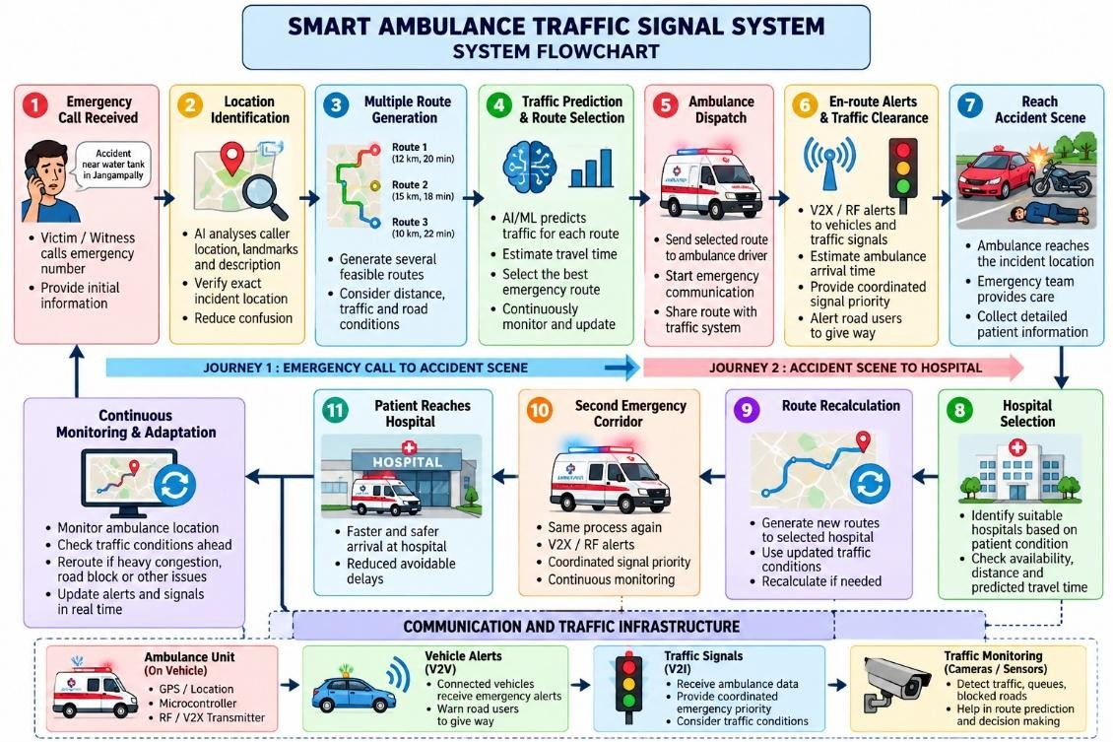
A flowchart for the solution
Once the hospital destination is selected, the system recalculates the route using the latest traffic conditions. The same emergency-corridor process is then activated again: route planning, traffic prediction, V2X/RF communication, driver alerts and coordinated traffic-signal priority are used along the route to the hospital. If traffic conditions change during transportation, the system can reassess the route and support a safer alternative when appropriate.
Thus, the proposed system does not treat an ambulance as simply another vehicle approaching a traffic signal. It treats the entire emergency journey as a continuously changing process. The objective is to reduce avoidable delays, improve location and route information, prepare traffic infrastructure in advance, increase awareness among road users, coordinate multiple intersections and help the ambulance reach the patient and hospital as efficiently and safely as possible.

Proposed Technologies
Technology | Proposed use in the system
AI / Machine Learning | Predict traffic conditions, assist incident-location identification, compare possible routes and support dynamic route selection.
GPS & GIS Mapping | Track ambulance position, identify the incident location, map routes and locate suitable hospitals.
Dynamic Route Planning | Generate multiple possible routes and continuously select a suitable route based on current and predicted traffic.
RF Communication | Low-cost prototype communication between the ambulance module and traffic-signal module.
V2X Communication | Future communication between the ambulance, connected vehicles and roadside infrastructure.
Microcontroller | Processes the RF/V2X-related signals and controls the prototype traffic-signal system.
Traffic Sensors / Cameras | Detect traffic queues, blocked intersections and changing road conditions.
ETA-Based Signal Coordination | Estimate ambulance arrival time and prepare upcoming traffic signals before the ambulance reaches them.
Driver Alert System | Warn nearby road users about the approaching emergency vehicle and encourage safe yielding.
Hospital Information System | Support selection of a suitable and reachable hospital using emergency facilities, availability and predicted travel time.
Real-Time Monitoring & Re-routing | Continuously monitor the emergency corridor and change the route when unexpected congestion or blockage occurs.
Team name: Team Lifeline
Team members:
- Malavath Rithvik (10th CS)
- Kuncham Hadvitha (9th VSB)
- Chatla Bala Thrushna Dattu (9th AB)
School name: SPR High Sch ool, Kamareddy

